Summer Internship

Report

Submitted To: Submitted By:

Mr. Vinay Kunwar(Project Head) V Venkatesh  
 B.Tech, Mechanical  
 IIT Guwahati

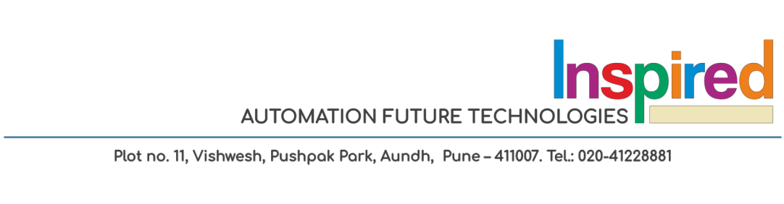

Contents

* MyRobotLab 3-5
* Google’s Translation APIs 6
* Google’s DialogFlow 7
* installing python and opencv 8-11
* Resourses for opencv 12
* Using Kinect basic examples 13

myrobotlab software:

MyRobot Lab software Chatbot test

Testing for commands via voice:

Trained for answering 2 questions.

1. Hi

->hello! Welcome to roboseum.

1. where is robocafe  
   ->go towards right from here.

Tested in the webgui of myrobotlab which takes voice commands by using selected text to speech function and passes text commands to chatbot.

While testing, the two questions were asked again via voice.

Forwarded command:

1. Hi
2. where is Robo Café

Response which we got:

1. hello! Welcome to roboseum.
2. I’m working on the map.

Threre was a issue here as Robo and cafe were separate here.

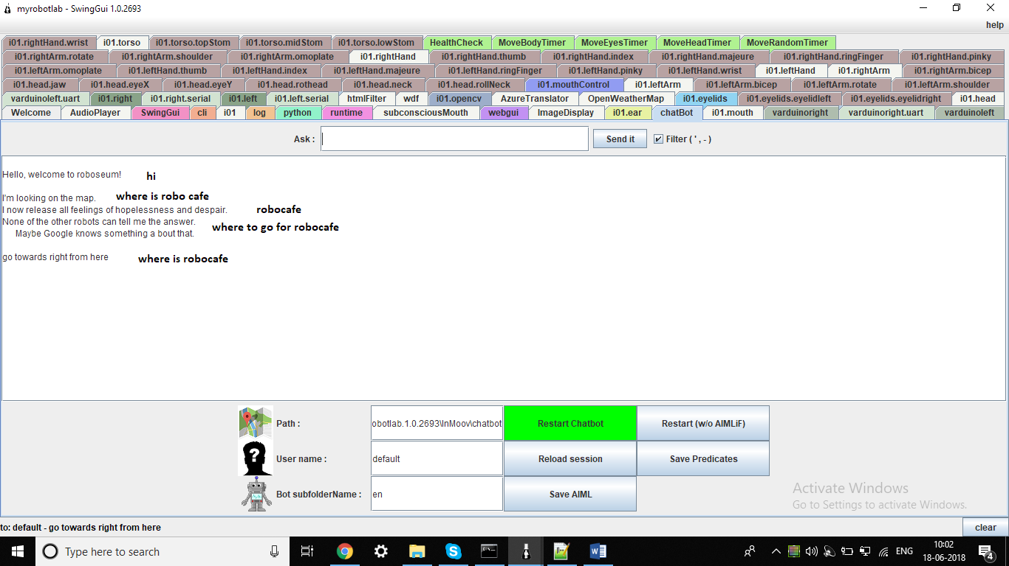

Trained for new question

* Where * robocafe

When asked the question “where can we find robocafe” or “where is the robocafe” the response was correct.

Caution- if are going to use this same chat bot then we have to give the main key words after verifying that our text to speech system recognises it exactly same.

The bot works for trained questions in English well. Like if we give the exact questions which people are going to ask, it will perform good and complete the task. But when the same question is asked with just minor changes like space in between then also it will fail.

Overall pros:

* Simple to handle and train for limited interaction.
* Webgui already readymade for voice interaction.
* Can be used offline without internet.

Overall cons:

* Not smart chat bot. Can’t understand user intent and works on strings completely. Every question has to be written in code properly.
* Not sure about using hindi and English at the same time.

Alternate options available:

Can use google’s API or other chat bot services which need an internet connection and a framework and new UI to work in and can be incorporated in here.

Training aiml files for required questions in English.

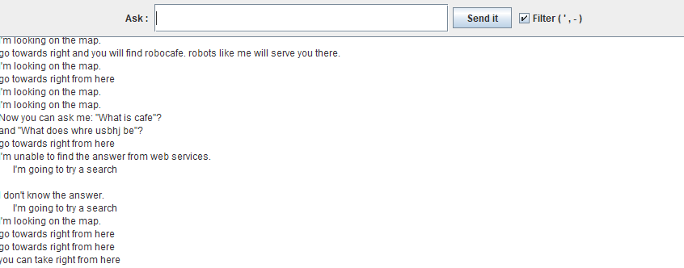

Location of aiml files of chatbot in webgui  
 myrobotlab.1.0.2693\InMoov\chatbot\bots\en\aiml

Things before adding question:

* Remove the existing questions with * from all the .aiml files by searching in all files from notepad++.
* Add the new questions and put * in grammar part.
* Try to give the starting word of sentence, that will make it better for chat bot.

Like “where * café”, “how * café”.

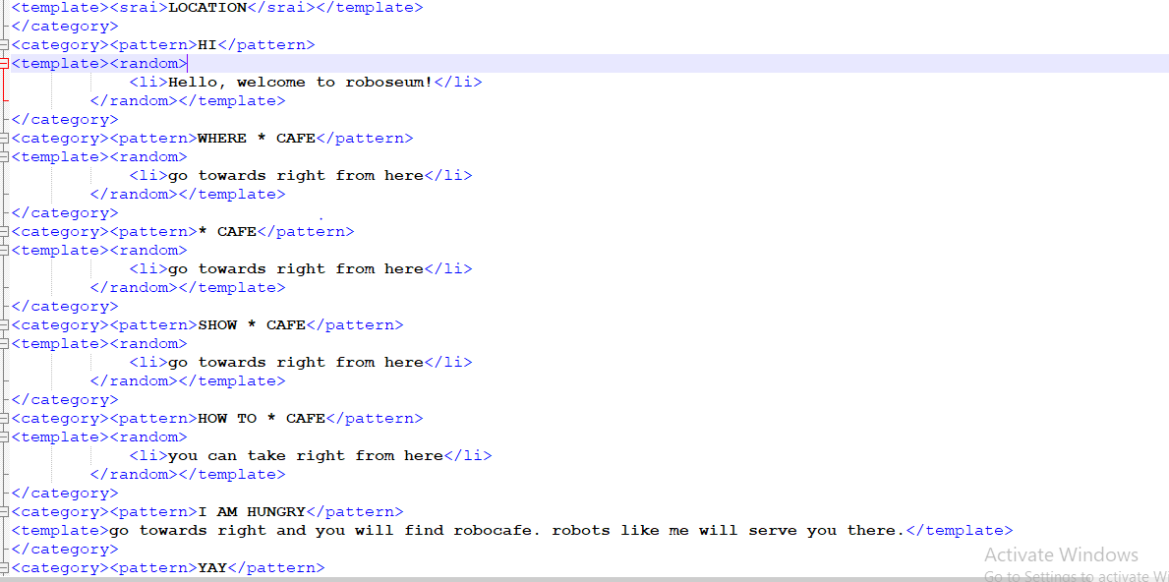

resourses for translation from one language to another(Python)

Basic tutorial for working with google translation apis.

<https://www.youtube.com/watch?v=chk2rRjSn5o&list=PLQVvvaa0QuDfGVb3yucqvKtUgwOJgZWCm&index=1>

Gujarati is supported good only by google apis. Google apis can convert speech to text in Gujarati well enough using natural language processing. And later on translate apis can be used to convert text to English. The work flow can be as follows:

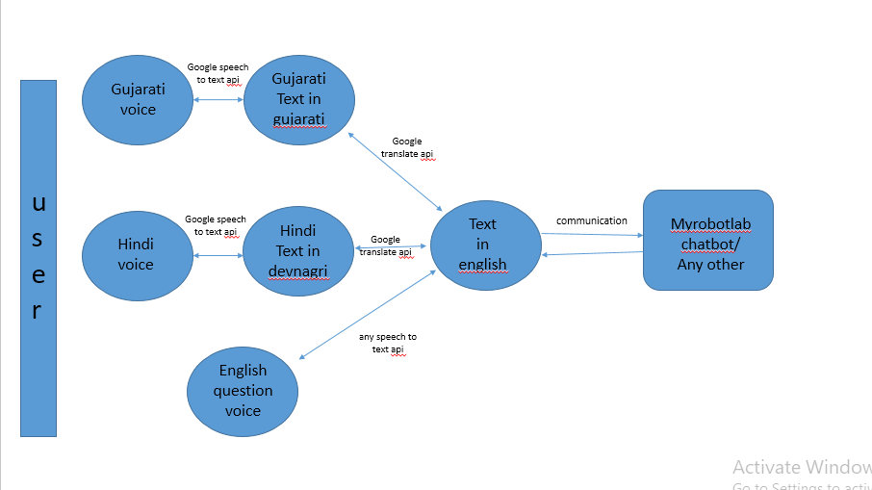

IBM speech services and Microsoft ones does not support gujarati. Found some speech to text converters for gujarati language but no specific things found for development purpose. Moreover translation to English is not at all available from any other source except google.

Requirements:

* An official account of google cloud platform from where apis are operated.

Issues currently facing:

Need help in communication part in flowchart as myRobotLab software is a little complicated and we need to see where the voice files and text files are currently getting stored in runtime.

DialogFlow

->for interactive chatbot and training this AI based service can be used.

Earlier Known as API.ai it is converted to simple GUI based training place for new chatbots to create.

Website: https://dialogflow.com/

Youtube Page: <https://www.youtube.com/channel/UC1EXoqvR9VrmWnM9S47SfVA>

this can be implemented in NAO and other projects as well.

Installing Python and opencv on windows

* Download python for windows from here: <https://www.python.org/downloads/>
* Install it and set the location you are installing manually for further ease(preferably in C:\)
* Open file explorer->right click this PC->properties->advanced system settings->environment variables->double click path->add location of python 36 to it by clicking new.

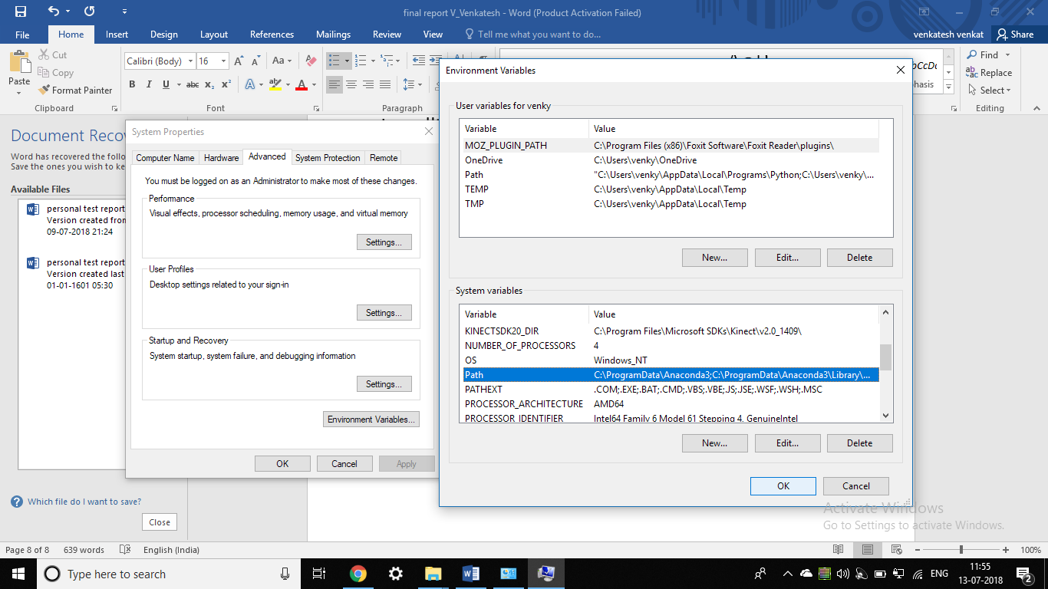

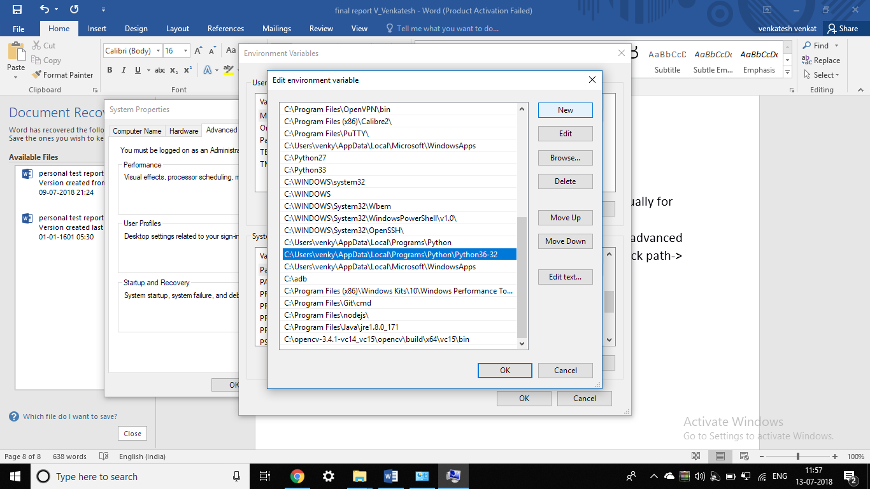

* Open windows powershell (admin)
* ->*command*(means enter command in powershell)  
  enter command:
* *->[Environment]::SetEnvironmentVariable("Path", "$env:Path;location inside of python36-32; location inside of python36-32\Scripts")*
* Enter python to see working or not.
* ->*exit()* if working.
* Check if pip is there by command ->*pip --version*
* else Install pip.

**Open CV** installing in windows

* *->pip install numpy*
* *->* *pip install opencv-python*

*For further needs refer :* [*https://pypi.org/project/opencv-python/*](https://pypi.org/project/opencv-python/)

Installing OpenCV in Ubuntu

Open terminal and follow these commands.

*->sudo apt-get update*

*->sudo apt-get upgrade*

*->sudo apt-get install build-essential cmake pkg-config*

*->sudo apt-get install libjpeg8-dev libtiff5-dev libjasper-dev libpng12-dev*

*->sudo apt-get install libavcodec-dev libavformat-dev libswscale-dev libv4l-dev*

*->sudo apt-get install libxvidcore-dev libx264-dev*

*->sudo apt-get install libgtk-3-dev*

*->sudo apt-get install libatlas-base-dev gfortran*

*->sudo apt-get install python2.7-dev python3.5-dev*

*->cd ~*

*->wget -O opencv.zip https://github.com/Itseez/opencv/archive/3.1.0.zip*

*->unzip opencv.zip*

*->wget -O opencv_contrib.zip https://github.com/Itseez/opencv_contrib/archive/3.1.0.zip*

*->unzip opencv_contrib.zip*

*->cd ~*

*->wget https://bootstrap.pypa.io/get-pip.py*

*->sudo python get-pip.py*

*->sudo pip install numpy*

*->cd ~/opencv-3.1.0/*

*->mkdir build*

*->cd build*

*->cmake -D CMAKE_BUILD_TYPE=RELEASE *

*-D CMAKE_INSTALL_PREFIX=/usr/local *

*-D INSTALL_PYTHON_EXAMPLES=ON *

*-D INSTALL_C_EXAMPLES=OFF *

*-D OPENCV_EXTRA_MODULES_PATH=~/opencv_contrib-3.1.0/modules *

*-D PYTHON_EXECUTABLE=~/.virtualenvs/cv/bin/python *

*-D BUILD_EXAMPLES=ON ..*

*->make -j4 //change 4 to number of cores on your processor*

*->sudo make install*

*->sudo ldconfig*

This should install opencv successfully for python.

Resourses for opencv

Open CV Documentation link:  
<https://docs.opencv.org/3.0-beta/doc/py_tutorials/py_tutorials.html>

Opencv python in short: [https://www.youtube.com/watch?v=Z78zbnLlPUA&list=PLQVvvaa0QuDdttJXlLtAJxJetJcqmqlQq](%20https:/www.youtube.com/watch?v=Z78zbnLlPUA&list=PLQVvvaa0QuDdttJXlLtAJxJetJcqmqlQq)

Very detailed vid tutorials for beginers:

<https://www.youtube.com/watch?v=dWeWCQmewLc&list=PLiHa1s-EL3vjr0Z02ihr6Lcu4Q0rnRvjm>

Opencv in c++:

<https://www.youtube.com/watch?v=l_4fNNyk1aw&list=PLAp0ZhYvW6XbEveYeefGSuLhaPlFML9gP&index=1>

A opencv python code for tracking disturbances has been attatched.

Using Kinect basic examples(C#,C++,VB)

Install Kinect SDK for windows from the following link:

<https://www.microsoft.com/en-in/download/details.aspx?id=44561>

Install developer tools for Kinect windows:

<https://www.microsoft.com/en-in/download/details.aspx?id=40276>

for installing pykinect2 wrapper of python on windows:

<https://github.com/Kinect/PyKinect2>

->can do this from windows powershell also.

Issues: After installation not able to capture the frames. A display window opens but not able to capture live feed. Still searching for what is wrong.